PDF iFilter Installation

W. Dale Miller (11-05-2020)

Make sure Adobe PDF iFilter is installed. Today, 11-05-2020, the current iFilter is Adobe PDF iFilter 11.

Make sure that PATH in environment variable(s) is set to the bin folder where you have installed iFilter in the previous step.

By default, the path should be “C:\Program Files\Adobe\Adobe PDF iFilter 11 for 64-bit platforms\bin\”. If you have selected custom path, then we need to provide a path to the bin folder.

Check the path of iFilter in SQL Server’s catalog view also.

SELECT *

FROM sys.fulltext_document_types

WHERE document_type LIKE '%pdf%'

Sometimes, we need to run below command so that iFilter is loaded correctly.

EXEC sp_fulltext_service 'load_os_resources', 1

GO

EXEC sp_fulltext_service 'verify_signature', 0

GO

Rebuild the INDEX

Now, if you can search few documents but not all, then you should check catalog population.

The PDF filter is not installed by default. So, for starters, we need to go download and install the [PDF ifilter](http://www.adobe.com/support/downloads/detail.jsp?ftpID=5542) (PDFFilter64Setup.msi).

This is a next, next, finish install:

[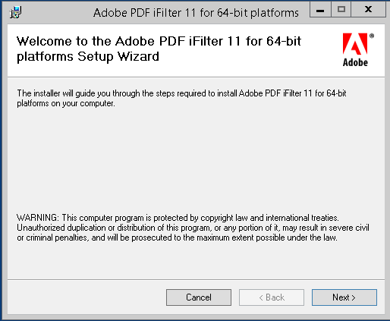](https://3.bp.blogspot.com/-7ShiGBEDBv4/V0dyPjd9F4I/AAAAAAAAARo/593yWU-DNrkzily_2OM97fy5OFkJW9KXgCLcB/s1600/Capture01.PNG)

[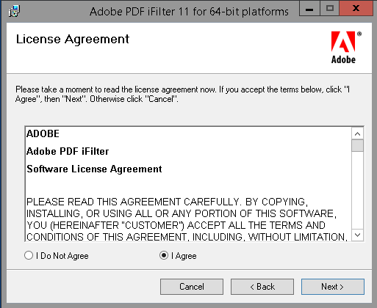](https://2.bp.blogspot.com/-9XI41VJ27LQ/V0dyPk36U3I/AAAAAAAAARk/Oasrx_7cy0gvZBt49-OOlnsDPpNYUZPXQCLcB/s1600/Capture02.PNG)

[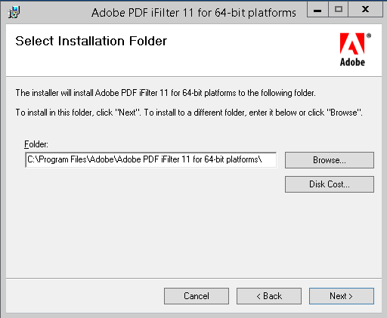](https://4.bp.blogspot.com/-0PbH9DO3K8o/V0dyPtkkLfI/AAAAAAAAARs/gDcSr45YEyYcwQgvUcJOjGuN1zXkREFlgCLcB/s1600/Capture03.PNG)

[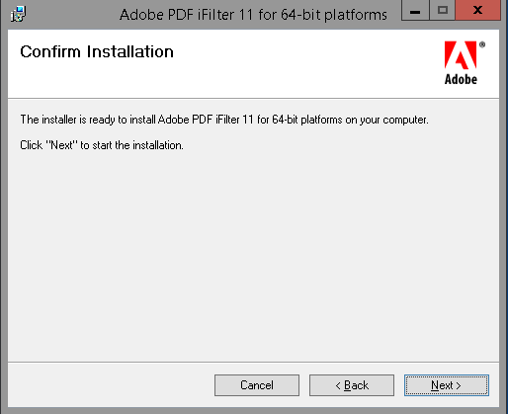](https://3.bp.blogspot.com/-EZtk_QnmM8k/V0dyP4xylkI/AAAAAAAAARw/7DniilV8ZCUvMj2p0KUCFYBK7G0g5UcQQCLcB/s1600/Capture04.PNG)

There is a trick with getting the installation setup correctly; you have to setup a system variable. Here's how I did it.

[https://1.bp.blogspot.com/--ZsQ69q1ST0/V0d3aqUNTmI/AAAAAAAAASQ/1GbllYjKDG83LTZgN4S6FpB0TflyfEhMgCKgB/s1600/Capture07.PNG](https://1.bp.blogspot.com/--ZsQ69q1ST0/V0d3aqUNTmI/AAAAAAAAASQ/1GbllYjKDG83LTZgN4S6FpB0TflyfEhMgCKgB/s1600/Capture07.PNG)

Environment Variables:

[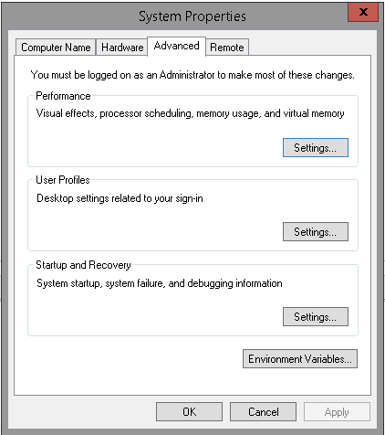](https://1.bp.blogspot.com/-2NFhrbTVuLE/V0d3alS3A8I/AAAAAAAAASU/-49U91AJBbcDDdTyQqMnyvebeMKc0u1VwCKgB/s1600/Capture08.PNG)

From Environment Variables I first created a new Variable "AdobeiFilter" and pointed it to the bin directory associated with the install:

[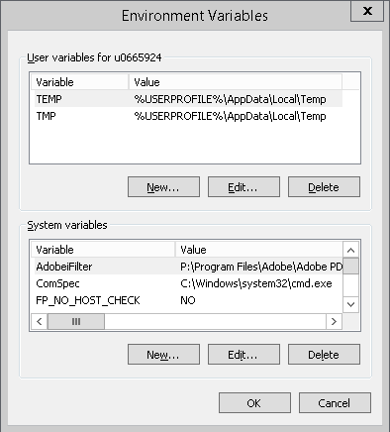](https://1.bp.blogspot.com/-pmcLiuNMD-8/V0d39AbQZEI/AAAAAAAAASc/GKD4cgIVWpMiIGHeIADYa16tsoY3ja8ZgCLcB/s1600/Capture09.PNG)

[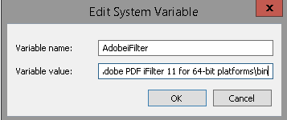](https://1.bp.blogspot.com/-GnlFZVOW7Tk/V0d39P6IUnI/AAAAAAAAASY/v6yapy2TkkgJFNCAH11aSEWCM3nUNBRdACKgB/s1600/Capture10.PNG)

I then clicked Edit on the Path Variable, in environment Variables, and appended %AdobeiFilter% to the end:

[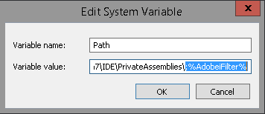](https://1.bp.blogspot.com/-Zad38S_TXDk/V0d4W2IG3FI/AAAAAAAAASk/qufEcpMiMY4-rLI7lEwJNIs3MpMRts67QCLcB/s1600/Capture11.PNG)

I can validate this by opening run and typing "%AdobeiFilter%" which drops me to my bin directory here: "C:\Program Files\Adobe\Adobe PDF iFilter 11 for 64-bit platforms\bin"

[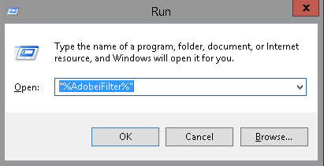](https://2.bp.blogspot.com/-U1TkLmh7pMk/V0d42AIkhMI/AAAAAAAAASs/-zUlLufrlcsQDLChNuBBfj9r0KNaXke-QCLcB/s1600/Capture12.PNG)

You may also need to grant your SQL Server Service account access to this folder.

Next we'll configure SQL Server Full-Text. You can check to see if it's already installed by running the following:

SELECT Serverproperty('IsFullTextInstalled')

If it's not installed you can run through the standard SQL Installation choosing "New SQL Server stand-alone installation or add features to an existing installation":

[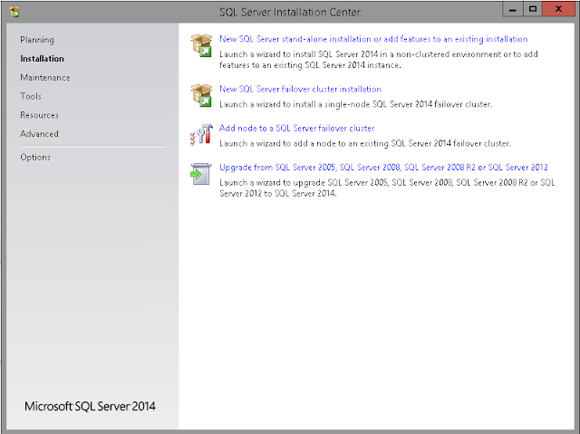](https://1.bp.blogspot.com/-6_jBLd5liRs/V0d0g6mOicI/AAAAAAAAAR8/FUQpSFwqD_4apHUkCXdqm0hh7RhiVD6gQCLcB/s1600/Capture05.PNG)

The feature is listed as "Full-Text and Semantic Extractions for search":

[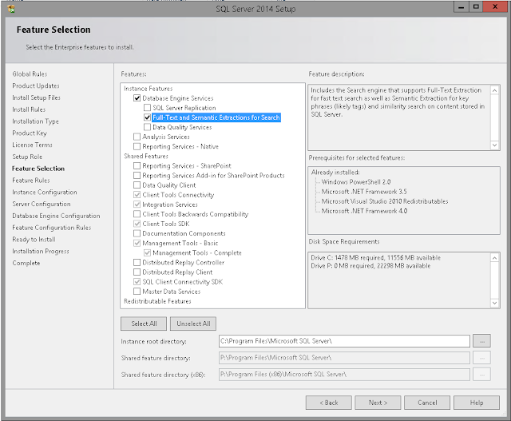](https://3.bp.blogspot.com/-sDwKG3RAH6U/V0d2W64S-PI/AAAAAAAAASI/h-xULCJEtvEbZfAfDnuWCg8ijvQI-UwewCLcB/s1600/Capture06.PNG)

Next we run a couple of [sp_fulltext_service](https://msdn.microsoft.com/en-us/library/ms175058.aspx) commands:

--Load operating system filters and word breakers

EXEC Sp_fulltext_service   
 @action='load_os_resources',   
 @value=1;

--Do not verify whether binaries are signed   
EXEC Sp_fulltext_service   
 @action='verify_signature',   
 @value=0;

Validate SQL is associating Full-Text and the PDF filter:

SELECT document_type,

path   
FROM [sys.fulltext_document_types](https://msdn.microsoft.com/en-us/library/ms174373.aspx)   
WHERE document_type = '.pdf'

You may need to restart the SQL Service, possibly the box, at this point if the association isn't there.